**Create a vector from with numbers sequence from 1 to 20 and print**

**values between 5 and 15.**

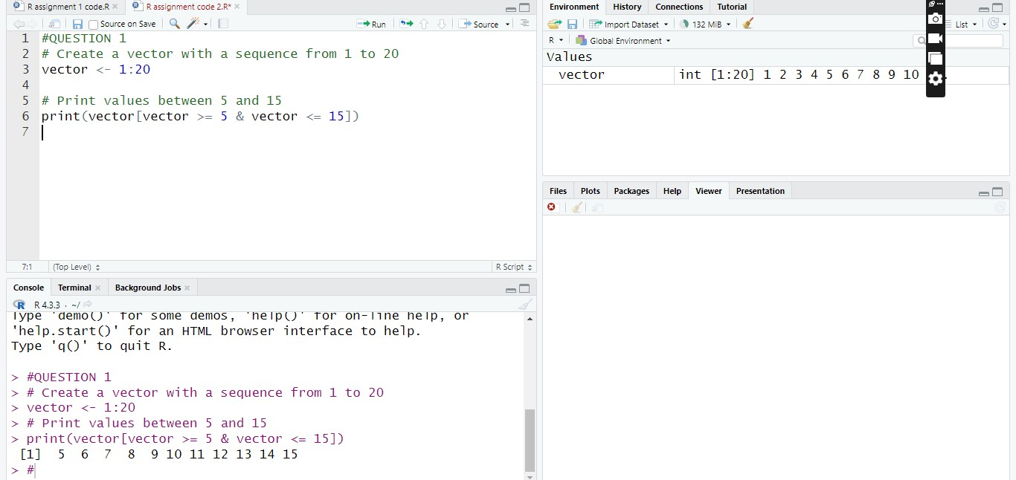

**Write an R program to create two 2x3 matrix, then add, subtract, multiply**

**and divide the matrixes.**

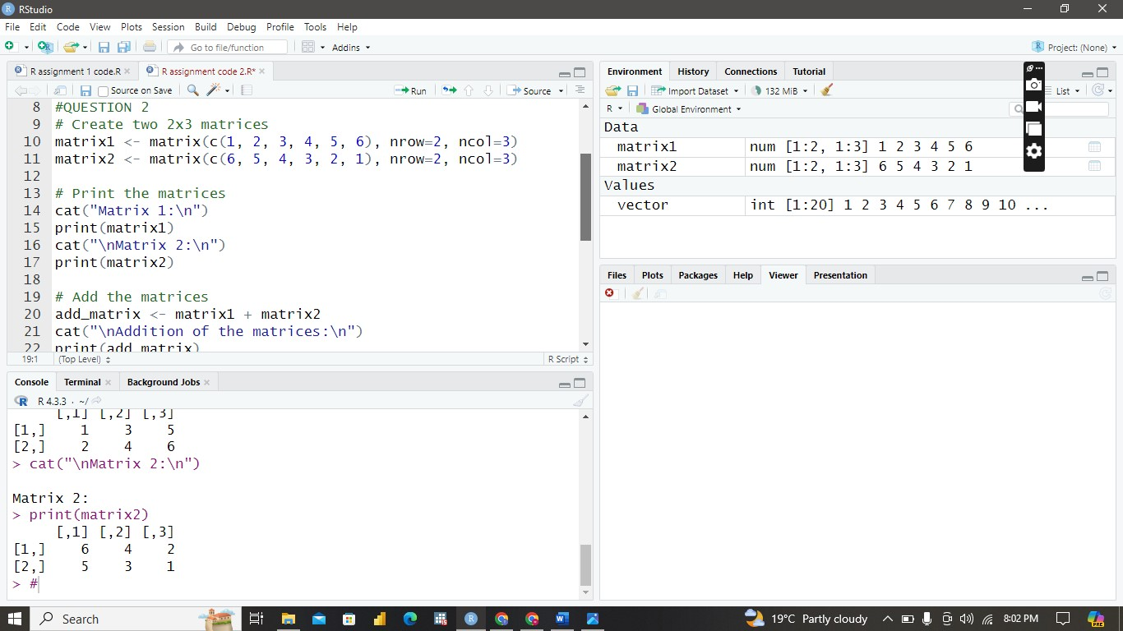

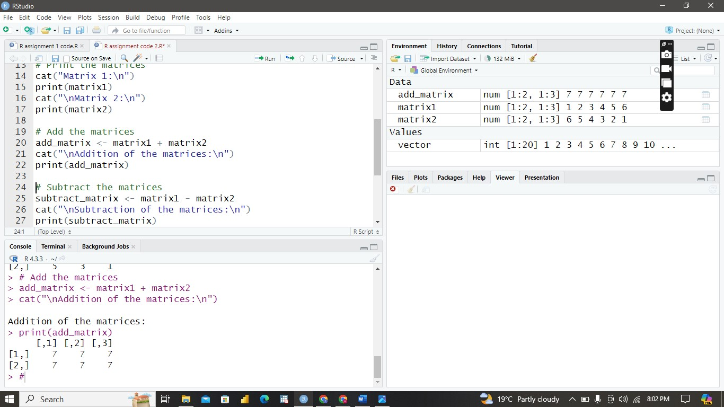

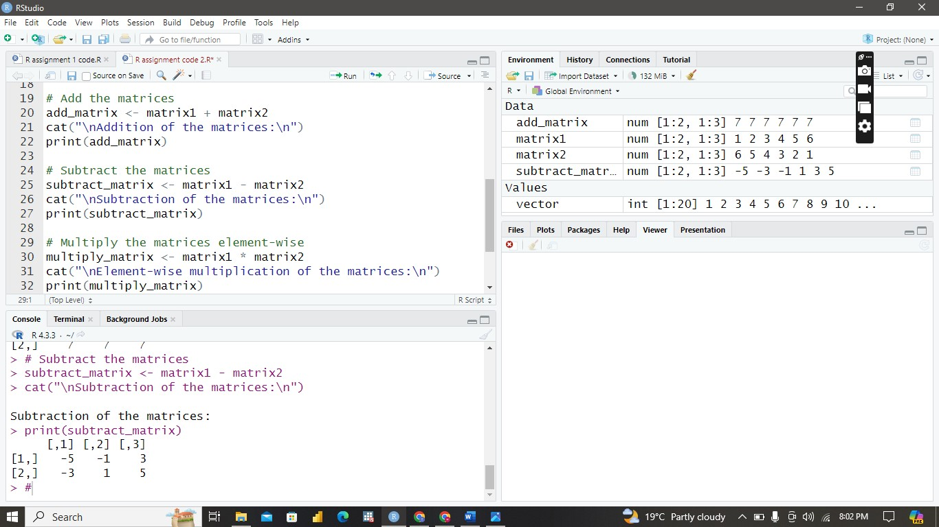

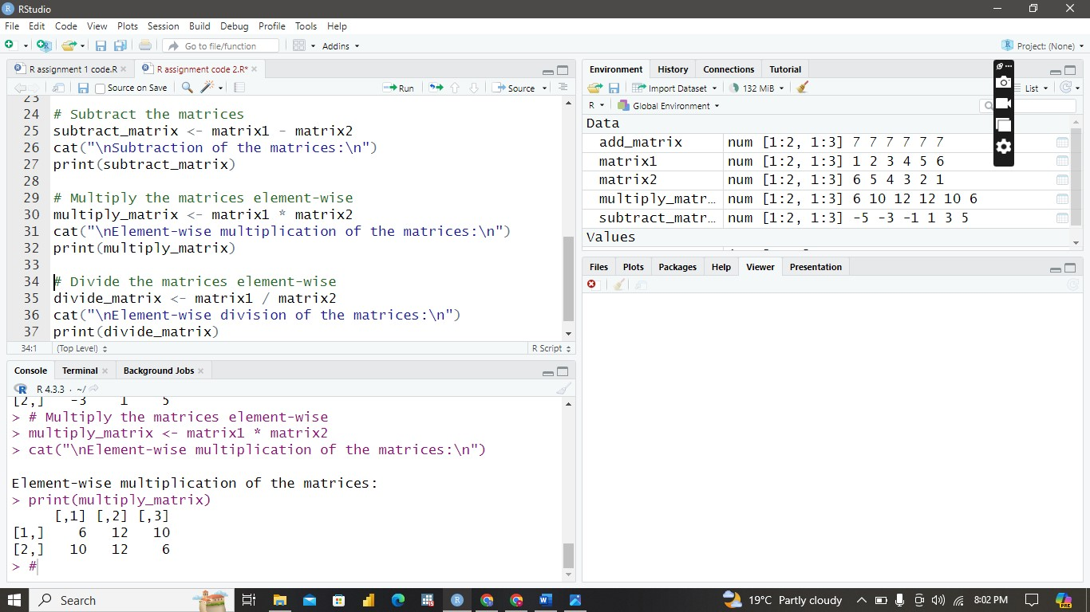

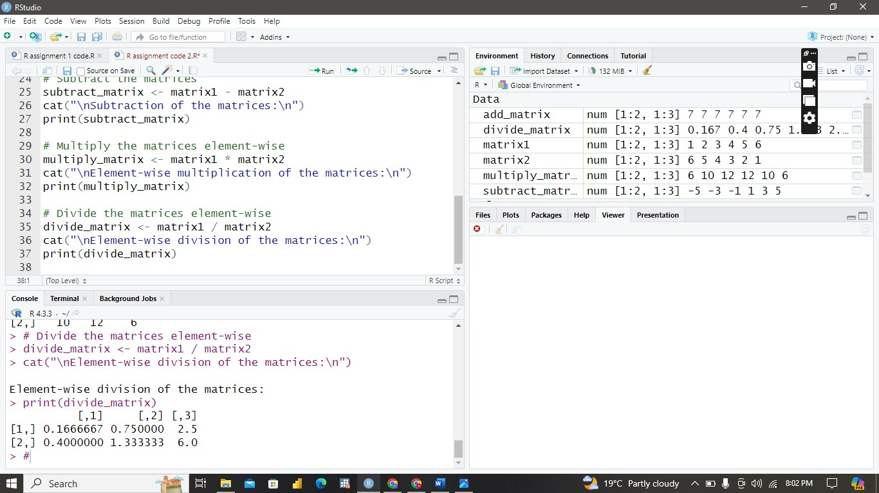

**Write an R program to create a data frame from at least 2 created vectors.**

